We were able to develop several insights about the data set during our analysis. One insight is that it is our conclusion that this data set is not a terribly effective for predicting HiWorth. The high number of Hiworth = 0 responses within the data set does not allow the JMP program to create a high degree of accuracy to predict Hiworth=1 in the training and validation phases with the given data. The lift curve of our best model shows that the top 20% of Hiworth = 1 entities is 2.65 times more likely to return a prediction of Hiworth = 1. Another insight is that the there are no Hiworth=1 individuals in the data set who resided in mobile homes and thus they should not be included in any future data collection for Oakhurst. There are Hiworth=1 individuals in the data set from both single-family homes both attached and detached, but the highest percentage comes from detached single-family homes which is categorized by Units = 2 as seen in the Mosaic Plot below.

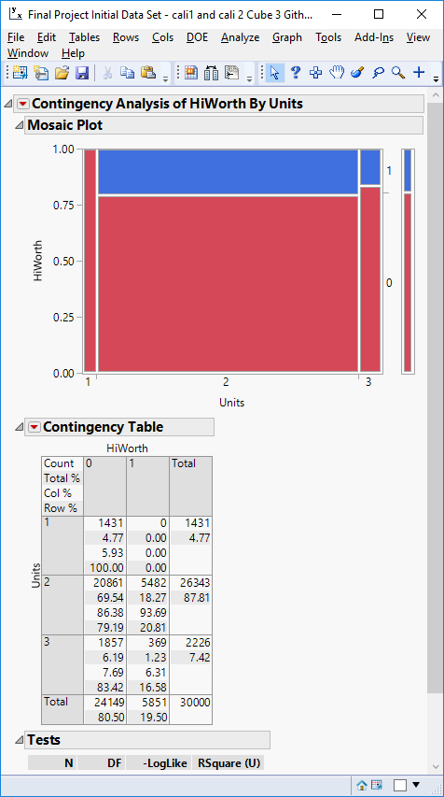

We also see in the mosaic plots below that higher percentage of individual with Hiworth=1 exist in Family = 1 representing a married couple. In the second plot we see that Tenure=1 which represents owned with a mortgage has a significantly higher response. Finally, we also see that slightly over one third of JuniorMtg = 2 representing Home Equity loan individuals were categorized as Hiworth=1.

